Assessment 1 - Part 2

(Prototyping User Interfaces)

# Conceptual Model

## Interaction models

*Multiple interaction models were used in the design of the site.*

*Instruction is used in the forms located in our site. An example of this is shown on the contact form/booking form where selections are being made on what the user wants to book and what information is being entered.*

*Manipulation can be a powerful tool when it comes to user interface design. Having the user being able to control the page and make them feel like they’re interacting with the page. And example of manipulation on our site is image expanding. When the user clicks on an image, the image then expands to full size on the screen to get a better view of what the image is displaying.*

## Interface Metaphors

*Interface Metaphors were used in the design of this site. The following are some examples of this. Social media icons are commonly used metaphors in which they imply that if you click on them they will take you to the corresponding social media page for this site. The nav bar is also a metaphor implies that the text in the nav bar will take you to the page/section relating to that one word.*

Low Fidelity

**Chris:**

* **“**The basic wireframe is simple and neat however I feel that it needs more color.**”**

**James:**

* **“**I like this website the booking system and login/signup system looks really good, I would like to see that the forms e.g. buttons are more visible and can be clearly seen

High Fidelity

**Chris:**

* **“**The use of color is vibrant and clean, I also really like the way the white space is used by the background patten**”**

**James:**

* **“**The button

# Low-fidelity prototype

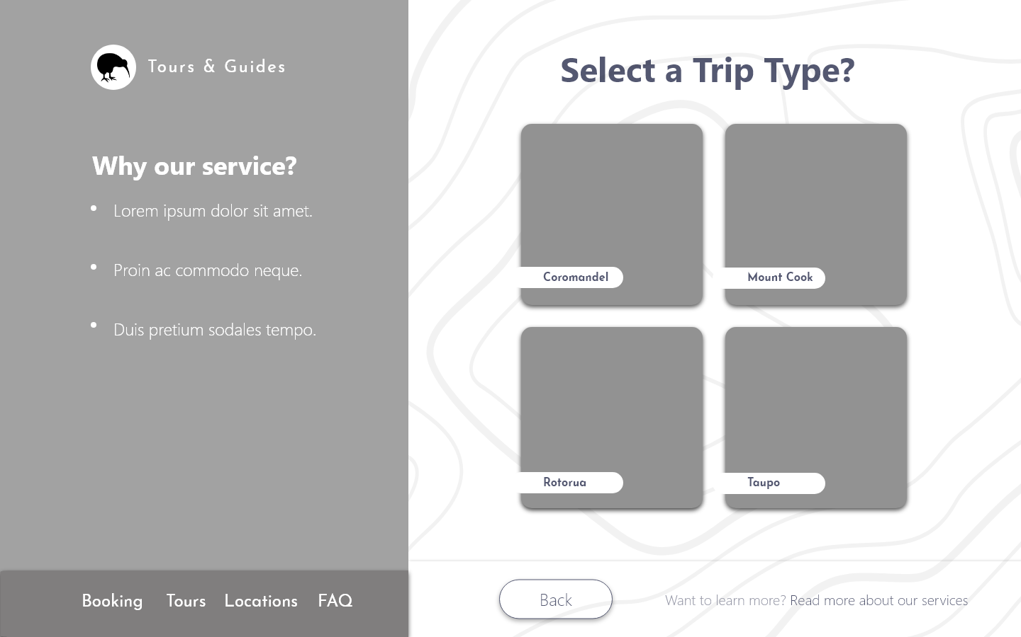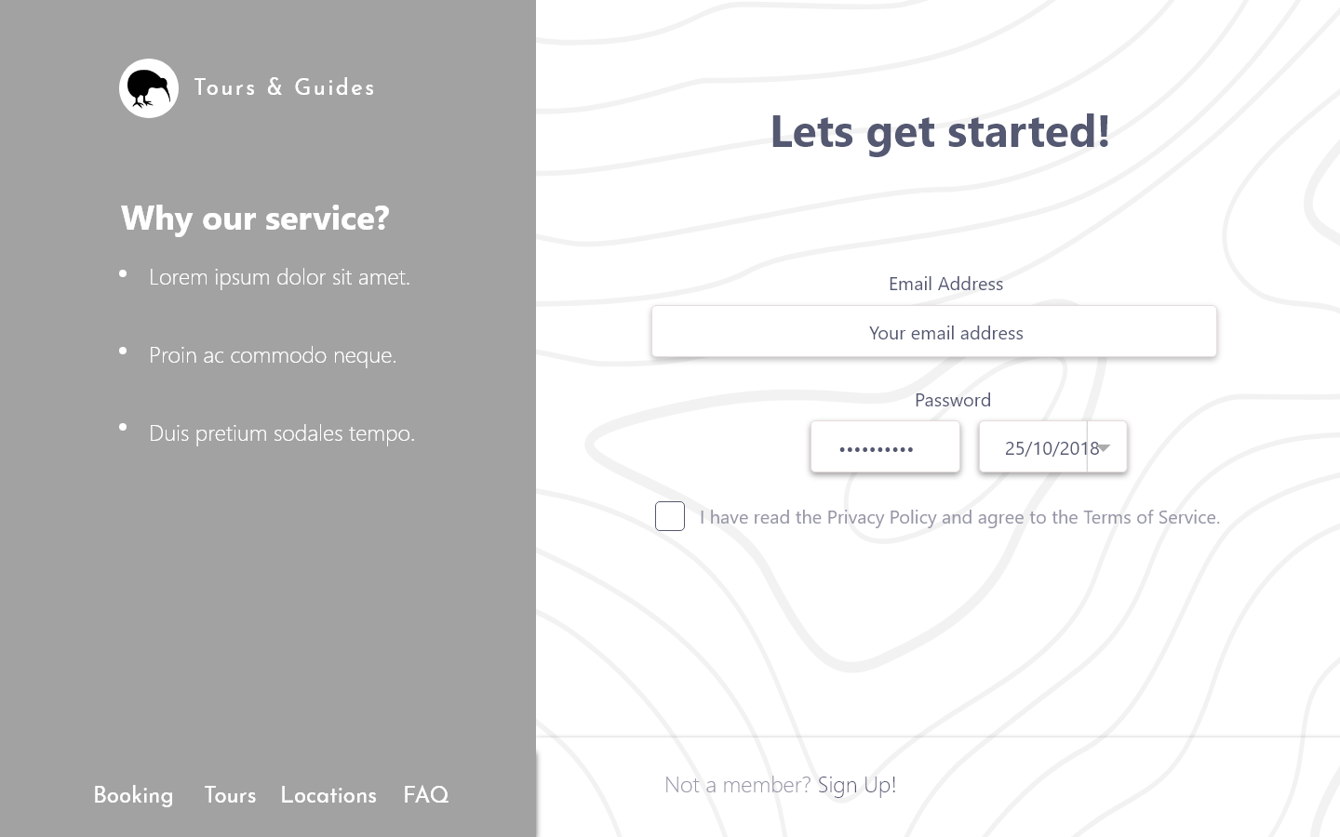

# High-fidelity prototype

## Screen Layout

*Our screen layout is split up into multiple segments containing a picture and a small amount of text. Its layed out this way so that the users don't suffer from information overload when reading the information on the site*

## Colour

*When selecting the colours for the site, we wanted to make sure that we captured the same vibrant beauty that New Zealand's has to offer. Keeping that in mind we wanted to keep the site looking smart and professional. So our group decided to go with navy blue. For the background a silver and white pattern was decided upon as stops the site from seeming boring with white space and yet is still not overly stimulating for the user so they do not get distracted*

## Navigation

*The navigation style is a simple point and click, A to B setup designed to minimise the use of sub pages to get to other pages. This is to make sure that the user does not get lost or overwhelmed when navigating our site.*